PHILIP STOCKBRUGGER
Wissenschaftlicher Mitarbeiter
Institut für Romanische Sprachen und Literaturen
Goethe-Universität Frankfurt am Main
Norbert-Wollheim-Platz 1, 60323
stockbrugger@em.uni-frankfurt.de
(+49) 17585615975

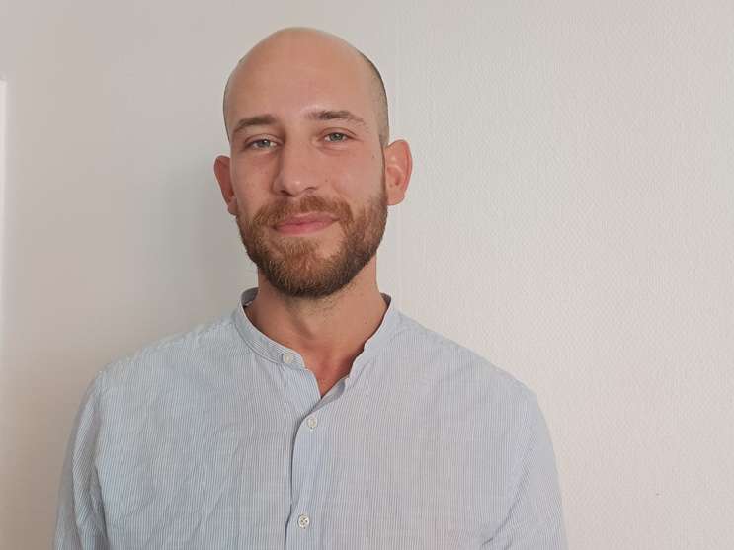

curriculum vitae

1986 Born in Bad Kissingen, Germany. Education first in Maastricht, The Netherlands, and then Ferrara, Italy, Liceo classico Ludovico Ariosto.

2010 BA (Laurea triennale) in Italian Literature at Pisa University (110/110 e lode) with a thesis entitled Giorgio Soavi narratore di artisti. Giacometti e Balthus.

2007-2010 Undergraduate student in the “Classe di Lettere e Filosofia” of the Scuola Normale Superiore in Pisa.

2013 MA (Laurea magistrale) in European Literatures and Philologies at Pisa University (110/110 e lode), with a thesis entitled Emilio Cecchi tra arti figurative e visività: Da Note d’arte a Pesci rossi.

2014-2020 Assistant Editor of “Hvmanistica. An International Journal of Early Renaissance Studies“.

2017 PhD at Pisa University in the disciplinary compartment Letteratura italiana, with a thesis entitled Traduzione e ricezione del romanzo barocco francese in Italia: Il ruolo dell’Accademia degli Incogniti. Tutor: Marcello Ciccuto. Reviewers: Pasquale Sabbatino, Fabio Scotto (final evaluation: Ottimo con lode – summa cum laude).

Since 2017 Wissenschaftlicher Mitarbeiter (Fellow) at the Institut für Romanische Sprachen und Literaturen of the Goethe-Universität, Frankfurt am Main.

Since 2017 Assistant Editor of the Journal “Deutsches Dante-Jahrbuchs“.

2017-2020 Editor of the compartment of Italian Literature for the “Romanische Bibliographie“ (De Gruyter).

Since 2019 Process of Habilitation for German Professorship. Working title of the dissertation: Biblischer Kommentar/Rolle des Gebets bei Paul Claudel, Charles Péguy und Max Jacob (Biblical commentary and prayer in Paul Claudel, Charles Péguy and Max Jacob).

Publications

Monographs

Il romanzo seicentesco tra Francia e Italia. Indagini intorno all’Accademia degli Incogniti, Fabrizio Serra, Pisa-Roma 2020. Enhanced version of the PhD dissertation.

Articles

- Giorgio Soavi narratore di artisti. I casi di Alberto Giacometti e Balthus, “Letteratura & Arte”, XI, 2013, pp. 111-158.

- Visività in Pesci Rossi. Arti figurative e prosa artiste, “Italianistica”, XLV, 2, 2016, pp. 107-132.

- Emilio Cecchi e Berenson: La nascita della 'visività', in Ut pictura poesis. Intersezioni di arte e letteratura, a cura di Pietro Taravacci/Erica Cancelliere, “Labirinti”, Trento 2016, pp. 231-276.

- Da Gli occhiali d'oro a Puttaneggiar coi regi di Gianfranco Rossi: Una riscrittura bassaniana, “Italienisch”, I, 2019.

- Mirroring authorization in Torquato Tasso’s Rime amorose, “Zeitsprünge” 2020, 24 (1), pp. 218-237.

- Commentary to Dante Alighieri, Divina Commedia, Paradiso XVII-XXXIII (Voll. 8-9), a cura di Marcello Ciccuto e Domenico De Martino, GEDI Gruppo Editoriale, Torino 2021. Celebratory edition of the Commedia, Dante 2021 - Comitato Nazionale per la celebrazione dei 700 anni / Società Dantesca Italiana.

- w. Christine Ott: Spiritualizing Petrarchism, “Poeticizing” the Bible: Two Counter-Reformation Self-Commentaries, “Glossator”, 2022, 12, pp. 131-154.

- Die Gerusalemme liberata in den bildenden Künsten, in Die Literatur zwischen den Medien, Edited by Gerhard Wild/Julia Fuchs, Winter, Heidelberg 2022, in preparation.

Edited Books

With Francesco Furlan and Marco Faini: Il Petrarca in Europa, “Dossier” of “Hvmanistica”, X, 1-2, 2015.

Rewiews

- Elisa Brilli, Firenze e il profeta. Dante fra teologia e politica, Carocci, Roma 2016, pp. 206-210.

- Kerstin F. M. Blum, Im Anfang war das Wort. Tom Phillips illustrativ-poetische Dante-Rezeption, University of Bamberg Press, Bamberg 2016, pp. 217-222.

Memberships

Since 2015 Founding Member of the international consortium “Artes Renascentes“, and since 2018 Membre correspondant of the same institution.

Since 2016 Reviewer for the International Journal “Dante e l’Arte”.

Since 2020 Member of the international consortium Frankfurt-Toronto “Practices of Commentary” (SSHRC Insight Grant, University of Toronto, 2020–2025).

awarded financing

5.000 Euros: Complete financing of the monograph Il romanzo seicentesco tra Francia e Italia. Indagini intorno all’Accademia degli Incogniti, financed thanks to the Forschungszentrum für historische Geisteswissenschaften.

1.000 Euros: Travel costs for the conference „Commenting and Commentary. The Historical Emergence of a Global Interpretive Mode”, University of Toronto, Centre for Medieval Studies (4 - 6.10.2019), financed thanks to the Forschungszentrum für historische Geisteswissenschaften.

Selection of Talks and Conferences

- Ringvorlesung (University Seminar) of the Romance Languages and Literatures Department, 2018/19 „Erzählung und Kommentar in den romanischen Literaturen“. Titel des Vortrags: Der Autorkommentar in den Rime von Torquato Tasso. 21.11.2018.

- Workshop „Practices of Commentary”, Goethe-Universität, 10.-12.12.2018. Title (with Christine Ott): A veil for my naked words. Commentary as auctorial strategy and as struggle with poetic ambivalence in the Italian Renaissance. 11.12.2018.

- RoMAna IV - Romanistisches Atelier für NachwuchswissenschaftlerInnen, Universität Marburg, 5.07.2021. Title of the talk: Le rime amorose con autocommento di Torquato Tasso, alcune proposte di lettura. 5.07.2019.

- International Conference „Commenting and Commentary. The Historical Emergence of a Global Interpretive Mode”, University of Toronto, Centre for Medieval Studies, 4.-6.10.2019. Title of the talk (with Christine Ott): Modes and Functions of Self-Commentary in the Sixteenth and Seventeenth Century. 5.10.2019.

- Ringvorlesung (University Seminar) of the Romance Languages and Literatures Department, 2019/2020 „Die Literatur zwischen den Medien“. Title of the talk: D’una pietosa istoria, e di devote figure la sua stanza era dipinta. Illustrationen der Gerusalemme von Torquato Tasso. 12.11.2019.

- Lecture at Bonn University, „Romanisches Seminar“. Title: Die Princesse de Clèves und der französische Barockroman. 13.01.2020.

- Colloquio Dottorato Internazionale di Italianistica Bonn-Firenze-Parigi “Il potere e le arti, il potere nelle arti”, Seminario di Studi intensivi, Paris, 9.06-11.06.2021. Titel des Vortrags: ‘Ma Capitano i’ son di gente eletta.’ Il personaggio di Goffredo di Buglione nella ricezione figurativa del Tasso. 10.06.2021.

Languages

Italian: Native speaker

German: Native speaker

Französisch: Level C2

Englisch: Level C2

Dutch: Level C2

